
November 2021 Volume 116

The Christmas Season is Upon Us…
Time to Celebrate Deň Sväty Mikulaš
(St. Nicholas Day) with the Sokols
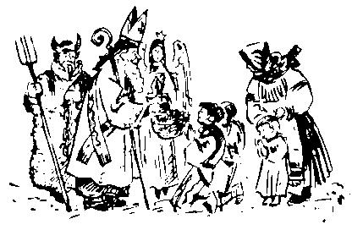
on Saturday December 4

After our 2020 Covid-19 cancellation last year…

WE ARE BACK!
Please come to the Slovak Home on Saturday December 4 beginning at 5 PM for good food, good live music and just a great time.... all the time supporting our Sokol Farrell gymnasts.
Page 1

Sit down service………………. $15.00
Takeout…………………………, 12.00
Children under 12 ………….…… 7.00
AND ……………………………. Free Hot dogs for kids!

All the food is homemade, delicious and we guarantee satisfaction. As he has recently, Rex Tenari will play with his orchestra for your listening and dancing pleasure. We have been doing this for so long… that this is the 3rd orchestra we have used. The first two have either retired or passed.

We are happy to say that the year before the Co-vid -19 cancellation, 2019 was our biggest and had the highest attendance since we began!!! Help us make this another banner year and continue the tradition. This year, we hope to see a few of our members who haven’t yet attended the event.

This social event is really a fun party and has been a tradition of our club since the 1980’s. It traces its beginnings to the Slovak tradition of celebrating St. Nicolas Day (Deň Sv. Mikulaš) on December 6th as a prelude to the Christmas season.

In Slovakia traditions vary in different regions. In some Slovak towns and villages, St. Nicholas, or Sväty Mikuláš arrives in a horse drawn sled, accompanied by an angel and a devil who rattles a
Page 2
chain. While waiting, children fill the streets with singing and dancing. St. Nicholas has a present for each child and in some villages, he visits each home.

On St. Nicholas Eve children carefully polish their boots to leave on the windowsill or at the doorstep. They hope to find a nice surprise the next morning and not the dreaded lump of coal. Traditional treats include apples, nuts, pears, or an orange. The evening of St. Nicholas Day older boys dress up as Mikuláš with his companions, an angel and a devil who has chains and wears bells at the waist. The trio visits families with young children, giving more fruit, nuts and candies. Before receiving treats, the children say a prayer or rhyme. In Bratislava the devil might give a potato instead of coal.

Of course, this tradition is not exclusively a Slovak one. In Serbia, Saint Nicholas the most widely celebrated family patron saint, is celebrated as the feast day of Nikoljdan. Since this day always falls
in the fasting period preceding Christmas, it is celebrated according to the Eastern Orthodox fasting rules. This entails the complete avoidance of animal-sourced food products (meat, milk, dairy products, and eggs). Fish may be eaten on certain days.
In Slovenia, Miklavž (Sveti Miklavž) and in Croatia, Nikolaus (Sveti Nikola) Saint Nicholas brings gifts
Page 3
to children commending them for their good behavior over the past year and exhorting them to continue in the same manner in the year to come. If they fail to do so they will receive a visit from "Parkelj" who traditionally leaves a rod, an instrument their parents will use to discipline them.

In Ukraine, St Nicholas (Mykolay) visits good children during the night 18–19 December and puts presents under the pillow. For the naughty children Mykolay brings a rod so parents can use it to discipline them. Usually Mykolay is accompanied by an angel (Janhol) and a Devil (Chort).

In Italy, St. Nicholas (San Nicola) is the patron of the city of Bari, where it is believed he is buried. Its deeply felt celebration is called the Festa di San Nicola, held on 7–9 May. In particular on 8 May the relics of the saint are carried on a boat on the sea in front of the city with many boats following (Festa a mare). As Saint Nicholas is said to protect children and virgins, on 6 December there is a ritual called the Rito delle nubili: unmarried women wishing to find a husband can attend to an early-morning Mass, in which they have to turn around a column 7 times.

Don’t be shy… DON’T MISS THIS!

Page 4


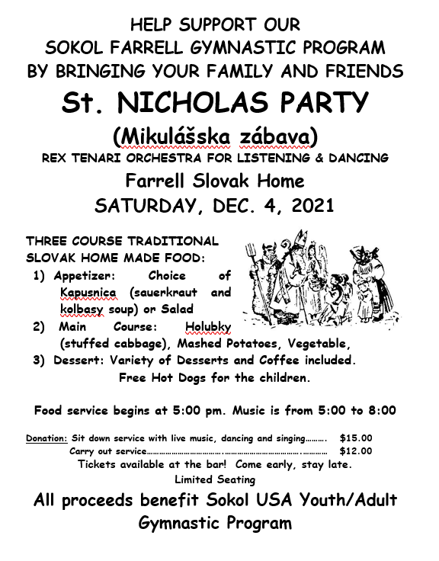
Page 5
Page 6

77th Anniversary of the Liberation of
Sokol Members Imprisoned in Auschwitz
Least We Never Forget!
(WARNING – GRAPHIC DESCRIPTION FOLLOWS)
On January 27, 2022 the whole world will mark the 76th anniversary of the liberation of the Auschwitz concentration camp. A large number of Sokol workers who were taken here without judgement went through the hell of this concentration camp. One of the handful of those who returned was the post-war President of ČOS brother Antonín Hřebík. He was one of the witnesses of the indictment of the Auschwitz commander after the war.
Karl Hermann Frank
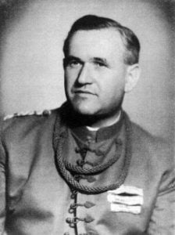
Read his appalling testimony published in the Sokol Gazette in 1946 and 1947 in the Czech language.
“The intervention against Sokol was led by Karl Hermann Frank, who as a Sudeten German knew the goals and attitudes of the citizenry. He remembered very well that it was the Sokols who supported and encouraged the Czech minority on the border.
Brother Antonín Hřebík
Post-WW II President of ČOS
After the German occupation of Czechoslovakia (*ed. Note: which began in 1938 with the German annexation of the Sudeten Land and was complete in 1939 with the invasion of the German army and the complete takeover. *), Sokol's activity was gradually impeded until it was completely stopped on April 12, 1941. At this time, many Sokol workers were already imprisoned. But that was not enough for Herr
Page 7
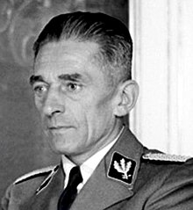
Frank, he wanted to destroy the Sokol and especially its workers. Already in the summer of 1941, the chief of ČOS brother Augustin Pechlát, who was the link between the Sokol resistance and the military, was arrested. After the arrival of R. Heydrich, it was K. H. Frank who informed him about Sokol and asked for another intervention against this organization. (*Ed. Note: Karl Hermann Frank (24 January 1898 – 22 May 1946) was a prominent Sudeten German Nazi official in the Protectorate of Bohemia and Moravia prior to and during World War II. Attaining the rank of Obergruppenführer, he was in command of the Nazi police apparatus in the Protectorate, including the Gestapo, the SD, and the Kripo. After the war, Frank was tried, convicted and executed by hanging for his role in organizing the massacres of the people of the Czech villages of Lidice and Ležáky.*)
(*Ed. Note: The Kripo (Kriminalpolizei) in Germany mostly consisted of plainclothes detectives and agents, and worked in conjunction with the Gestapo. In the concentration camps, they consisted mostly of German criminals.*)
Right on the first day, Heydrich had brother Augustin Pechlát executed. He and also those in charge of the Defense of the Nation, coincidentally also Sokols - Prime Minister A. Elias and General Hugo Vojt. The disaster occurred from October 7. to 8, 1941, when the Sokol event “Aktion Sokol ′′ started and when the Sokol officials, Chiefs and the Educational Bureau of the Czech Republic were arrested, including a number of county administrators, their deputies, business owners, chiefs and
Page 8
educators. They were taken first, to various Gestapo prisons and then taken to the police prison in Terezin. None of them were investigated, no criminal proceedings were introduced against any of them, but all were deployed in late 1941 and on the night of January 14. to 15, 1942 on direct orders from Frank to the hardest concentration camps with a note R. U. (Return unwanted ). The largest group was sent to Auschwitz and a smaller group also to Flossenbürg and to Mauthausen).
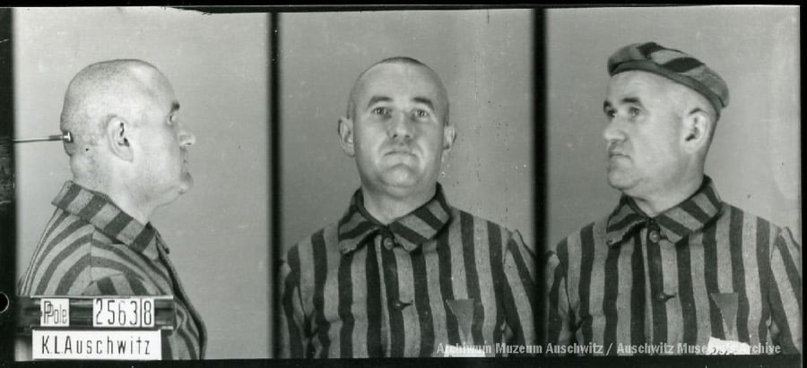
Until 1941 almost no one in Bohemia knew what Auschwitz was. But the SS men in Terezín knew it well. During the departure of the Sokols from Terezín, prisoners overheard an interview that Sokol action is K. H. Frank's mission and that they will go to Auschwitz. When they asked the SS men who accompanied them, what Auschwitz was and where it was, they laughed at that and that they would know it was known as, ′′Knochenm ühle′′ - bone mill, while others referred to Auschwitz as “Jordlager” – dirt storage. The prisoners would soon see for themselves.
Prison number
25 638,
Antonín Hřebík
Let the former President of Sokol, brother Antonín Hřebík, who was among the prisoners and was lucky enough to be included in this terrible calvary of Sokol martyrs, to survive, leave a testimony for generations to come. As a witness to the process, brother Antonín Hřebík presented his testimony:
′′ Upon our arrival in the most horrible winter, we had to strip naked and stand in the yard in 35 degrees weather, waiting for a tour of the facility. Naked, we were brought from block to block, after showering with hot water we had to go outside again in the cold. So, already in the first few days the first of us died of pneumonia.
Page 9
We understood that we would be treated in such a way that no one returns. Life in Auschwitz was unbearable. Back then, there were not such a large range of gas chambers, but it was arranged differently. There were German criminals who were charged with supervision in the camp. They made sure prisoners died as quickly as possible. There was little space in Auschwitz. New transports were still coming and at the end of 1941 and at the beginning of 1942 at least 6 prisoners had to die every month in order to accommodate 6 new ones.
Our accommodations were terrible. We laid on the ground, windows open to freezing weather, flimsy blankets and no food. Only 48 hours after our arrival we were able to eat. Food in Auschwitz looked like we got a bowl of turnip soup every day, we had to scrounge dirty bowls from each other. We did not get spoons, so we had to eat thick parts of the soup with dirty hands. We were dirty because there was no water supply on some blocks in Auschwitz and we couldn't even wash. Water flowed only in the toilet, and whoever allowed himself to wash a little bit in the toilet was beaten raw.
Right in the first few days we started going to work. It was the hardest job they could have invented for us. We had to for example, carry 50 kg bags of cement on our backs all day, sometimes digging frozen clay out of the cement. Imagine how the suffering of old prisoners was; those who were over 70 years old, who were in the right sense of the word, unable at work. Kripo (mostly German criminals) with strong sticks in their hands were looking after prisoners who could not work; they beat them roughly. It used to happen that when we came to our barracks from work in the evening, many of us with broken skulls, bloodied; we had to carry the dead on our backs. Even
Page 10
the dead had to approach an appeal in the evening. The Kripo who brought the prisoners back did not have to explain why they beat any one of the prisoners, but they had to be correct with the number and therefore the dead and dying were piled up on the left side. It often happened that our brothers and friends were lying on this left side in the mud or snow, dying and no one was allowed to help them. When someone wanted to help, they were themselves beaten and cut fiercely.
After a full day of exhaustive work we had to start the so called at night ′“Ehrenarbeite′′ - Honor Work, numerous jobs that built new blocks for more and more prisoners - in the freezing cold and sleet, hungry and thirsty and often with severe disease.
Even after the end of work, however, our suffering was not over. They were called, “Sachenapels”, when the guards were looking for someone who still had good clothes on. For example, when it was raining all day and we spent the whole day in the mud and we had nothing to change into, or at least if we cleaned our clothes, new penalties were coming. The prisoner had to undress himself naked, stand on the cement floor at a window that was opened and for three or more hours, had to stand there. It was natural for such prisoners to die quickly from pneumonia. Sometimes the prisoners during freezing cold, had to stand barefoot on cement floors and learn German songs with open windows and then had to scream the songs so loud that the camp commander could hear it through the open windows.
The hygienic conditions were terrible. We were in dirty clothes for from 6 to 8 weeks; full of lice everywhere. Two prisoners slept on one bunk; typhoid and dysentery spread and the sick were treated like cattle. Dozens of prisoners were dying in the block, and at night those who died were thrown naked on the street. So, it happened in the morning that there was a whole bunch of 70 and more dead twisted bodies before each block and often to our horror we saw that there were some prisoners who were still moving. Corpses were loaded on carts with pitchforks that had rounded spikes, like some manure and then drove to the crematorium.
Page 11
When the camp manager seemed like someone wasn't dying fast enough, tours were held. The weak and starved to the bone were sent to Birkenau for a ′′ light job”. This was a camp that was a part of Auschwitz, but the conditions there were even worse. There was no water at all, there were no toilets, living in barns and the cruelest criminals were the leaders. 14 prisoners were transported to Birkenau in 4 weeks. Others were beaten and destroyed here within a few days. When the prisoners went to work, the ones who did not go fast enough, got hit in the head and fell with a shattered skull on the road or into a ditch. That's where they were collected after ”wungork”.
When a prisoner was wounded, not killed, just stunned, they put a noose on his neck and the Kripo swung it from side to side until he suffocated the prisoner. Who did not die of a disease or was not beaten, died of a so-called. natural death. Food was bad and never enough. In a few weeks everyone looked like a moving corpse. When the body had nothing to take from, the heart testified.
Such was the treatment that of all the Sokol workers who were sent by K. H. Frank without condemnation to Auschwitz, only about 9 % remained alive. That this was really Frank's action, is confirmed by the documents found in the archives after the war and were signed exclusively by K. H. Frank.
Until 1941 there was no idea what Auschwitz was in Bohemia. Only at the end of 1941 and early 1942, when news of the fierce dying of Sokol nationals, who were transported to Auschwitz, of which only about 70 persons remained in 5 months, did the whole nation realize what Auschwitz was."
Page 12
During the inquiry with the commander of the concentration camp of Auschwitz, of R. H Őssem, Professor Dr. Olbrycht said, “he was a connoisseur of the process: Dante's hell appears to be an innocent entertainment venue at Auschwitz..." He and other witnesses recounted the unimaginable horrors that took place in this concentration camp, which spread to 40 km2. According to the experts' testimonials, 98 % of prisoners became permanently sick of total exhaustion. Prisoners lost weight up to 30 kg and were murdered by the thousands for their inability to work. The prosecuting fact is that in Auschwitz, they had one pill of aspirin to cure five hundred sick people.
On blocks that were furnished for 200 people, there were 300. The ubiquitous insects were the cause of contagious diseases, especially typhus. Three crematoriums, which contained 46 kilns, at first burned 10 people per day, and in the summer of 1944, they reached a record of 24 000 people per day. Only thanks to the rapid advancement of the front, the devil's plan for another powerful crematorium was no longer implemented, which would contribute to the extermination of all nations.
Processed by Mgr. Pavlína Špatenková
Posted on Facebook by Sokol Dvůr Králové, Czech Republic on Sunday January 24, 2021 -Some editorial notes by Stephen Banjak
Page 13
We are in Sokol Farrell’s 116th year and will conduct our next continuous regular monthly meeting on Tuesday 12/07/21 at 7:00 PM in our meeting room. Please plan to attend.

Time To Register For…

SOKOL USA FARRELL’S
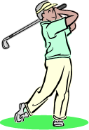
13th Four Person Open Golf Scramble

Possibly the Very Best in
Western Pennsylvania!

June 11, 2022
Shenango Lake Golf Club
99 Birchwood Drive; Transfer, PA 16154

Please Go to Our Website for Registration and Donation Forms
http://www.sokolfarrell.org/home.html

Entries Accepted on “First Come” basis. Limit of 30 teams.

Chairman: Bro. Tim Brandt

Page 14

